**REPUBLIC OF CAMEROON**

**Peace-Work-Fatherland**

**REPUBLIQUE DU CAMEROON**

**Paix-Travail-Patrie**

Internship carried out from the 1st of July to the 30th of September 2024 at Welldone Planet Cameroon as part of my pursuit to obtain a

**Higher Technician Diploma (HTD)** **in Software Engineering**

**Submitted by:**

**TCHABAT TCHOUATE PETTANG Valier**

**Level II Student at AICS/IAI Cameroon**

**SUPERVISION**

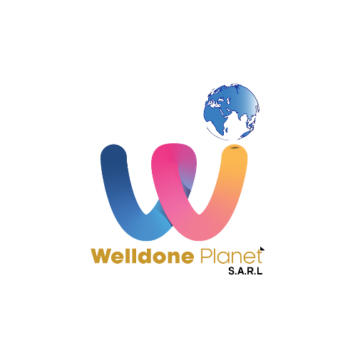

THEME :

CONCEPTION AND IMPLEMENTATION OF A MOBILE APPLICATION FOR LAUNDRY PICKUP AND DELIVERY

Academic Supervisor :

**Mrs. ONGUENE Ebenye**

Lecturer at AICS/IAI Cameroon

Professional Supervisor :

**Mr. TIOMELA JOU Daniel** IT Engineer



**AFRICAN INSTITUTE OF COMPUTER SCIENCE – CAMEROON OFFICE**

**Paul BIYA Technological Center of Excellence**

P.O.BOX : 13719

Tel : (+237) 242 72 99 57 / 242 72 99 58

E-mail : [contact@iaicameroun.com](mailto:contact@iaicameroun.com)

Web Site : www.iaicameroun.com

**INTERNSHIP REPORT**

**Welldone** **Planet**

**Inspirer l'excellence, Réaliser l'innovation, Rêvons Grand**

Yaoundé - Nsam, Carrefour Colombia

+237 677 223 241 / 655 834 753

[welldoneplanet@gmail.com](mailto:welldoneplanet@gmail.com)

[www.welldoneplanet.com](http://www.welldoneplanet.com)

2023 – 2024

Academic Year